Day 3 SQL bootcamp assignment

/*q1. Update the categoryName From “Beverages” to "Drinks" in the categories table.*/

update categories set category_name ='Drinks' where category_name = 'Beverages';

select * from categories;

/* q2. Insert into shipper new record (give any values) Delete that new record from shippers table.*/

select * from shippers;

insert into shippers (shipper_id, company_name, phone) values(7, 'USPS', 1234567890);

delete from shippers where shipper_id=7;

/*q3. Update categoryID=1 to categoryID=1001. Make sure related products update their categoryID too. Display the both category and products table to show the cascade.

Delete the categoryID= “3” from categories. Verify that the corresponding records are deleted automatically from products.

(HINT: Alter the foreign key on products(categoryID) to add ON UPDATE CASCADE, ON DELETE CASCADE)*/

alter table products drop constraint if exists fk_products_categoryid_fkey;

ALTER TABLE products

DROP CONSTRAINT fk_products_categories;

alter table products

add constraint products_category_id_fk

foreign key (category_id)

references categories(category_id)

on update cascade

on delete cascade;

update categories

set category_id=1001

where category_id=1;

select * from categories;

/*q4. Delete the customer = “VINET” from customers. Corresponding customers in orders table should be set to null (HINT: Alter the foreign key on orders(customerID) to use ON DELETE SET NULL

)*/

alter table orders

drop constraint if exists orders_customerid_fkey;

ALTER TABLE orders

DROP CONSTRAINT fk_orders_customers;

alter table orders

add constraint orders_customerid_fkey

foreign key (customer_id)

references customers(customer_id)

on delete set null

delete from customers

where customer_id='VINET'

select * from customers where customer_id='VINET';

select * from orders where customer_id='VINET';

/*Q5. Insert the following data to Products using UPSERT:

product_id = 100, product_name = Wheat bread, quantityperunit=1,unitprice = 13, discontinued = 0, categoryID=5

product_id = 101, product_name = White bread, quantityperunit=5 boxes,unitprice = 13, discontinued = 0, categoryID=5

product_id = 100, product_name = Wheat bread, quantityperunit=10 boxes,unitprice = 13, discontinued = 0, categoryID=5

(this should update the quantityperunit for product_id = 100)*/

insert into products (product_id, product_name, quantity_per_unit,unit_price,discontinued,category_id)

values (100,'Wheat bread',1,13,0,5),

(101,'White bread',5,13,0,5)

on conflict (product_id)

do update

set product_name = EXCLUDED.product_name,

quantity_per_unit=EXCLUDED.quantity_per_unit,

unit_price= excluded.unit_price,

discontinued= excluded.discontinued,

category_id = excluded.category_id;

insert into products (product_id, product_name, quantity_per_unit,unit_price, discontinued, category_id)

values (100,'White bread',10,13, 0,5)

on conflict (product_id)

do update

set product_name = excluded. product_name,

quantity_per_unit =excluded. quantity_per_unit,

unit_price = excluded.unit_price,

discontinued = excluded.discontinued,

category_id = excluded.category_id;

select * from products where product_id =100 or product_id= 101 ;

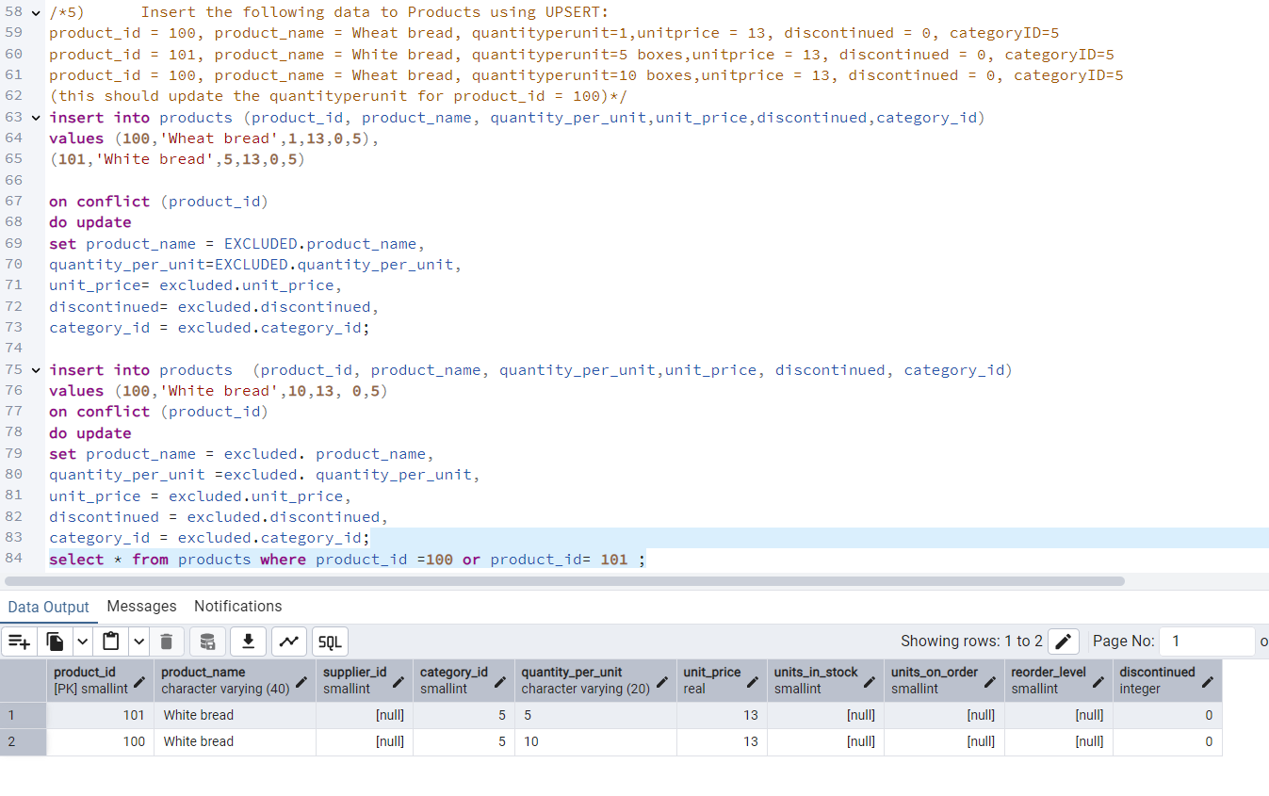

Q6.       Write a **MERGE query**:

Create **temp table with name:**  ‘updated_products’ and insert values as below:

|  |  |  |  |  |  |
| --- | --- | --- | --- | --- | --- |
| productID | productName | quantityPerUnit | unitPrice | discontinued | categoryID |
| 100 | Wheat bread | 10 | 20 | 1 | 5 |
| 101 | White bread | 5 boxes | 19.99 | 0 | 5 |
| 102 | Midnight Mango Fizz | 24 - 12 oz bottles | 19 | 0 | 1 |
| 103 | Savory Fire Sauce | 12 - 550 ml bottles | 10 | 0 | 2 |

* Update the price and discontinued status for from below table ‘updated_products’ only if there are matching products and updated_products .discontinued =0

* If there are matching products and updated_products .discontinued =1 then delete

* Insert any new products from updated_products that don’t exist in products only if updated_products .discontinued =0.

CREATE TEMP TABLE updated_products (

productID INT PRIMARY KEY,

productName VARCHAR(50),

quantityPerUnit VARCHAR(50),

unitPrice NUMERIC(8,2),

discontinued int,

categoryID INT

);

INSERT INTO updated_products (productID, productName, quantityPerUnit, unitPrice, discontinued, categoryID)

VALUES

(100, 'Wheat bread', '10', 20, 1, 5),

(101, 'White bread', '5 boxes', 19.99, 0, 5),

(102, 'Midnight Mango Fizz', '24 - 12 oz bottles', 19, 0, 1001),

(103, 'Savory Fire Sauce', '12 - 550 ml bottles', 10, 0, 2);

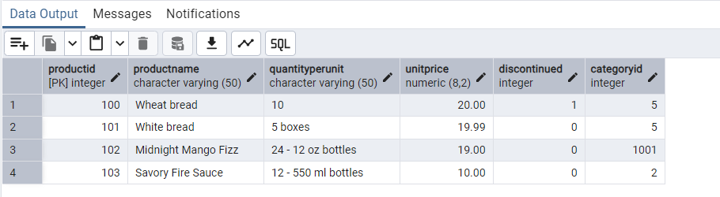

MERGE INTO products AS actual

USING updated_products AS temp

ON actual.product_id = temp.productID

WHEN MATCHED AND temp.discontinued = 0 THEN

UPDATE SET

unit_price = temp.unitPrice,

discontinued = temp.discontinued

WHEN MATCHED AND temp.discontinued = 1 THEN

DELETE WHEN NOT MATCHED AND temp.discontinued = 0 THEN

INSERT (product_id, product_name, quantity_per_unit, unit_price, discontinued, category_id)

VALUES (temp.productID, temp.productName, temp.quantityPerUnit, temp.unitPrice, temp.discontinued, temp.categoryID);

Select * from products WHERE category_id = 5;

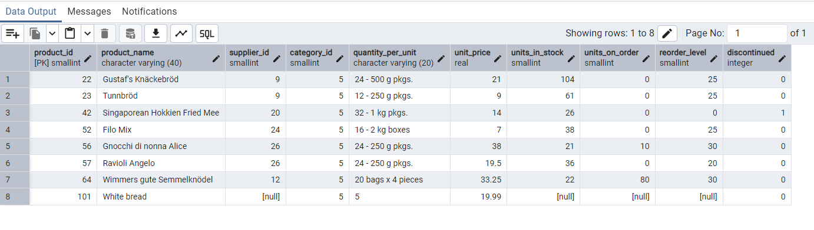

7)      List all orders with employee full names. (Inner join)

SELECT o.order_id, e.first_name || ' ' || e.last_name AS employeefullname

FROM orders o

INNER JOIN employees e ON o.employee_id = e.employee_id;

